Basics

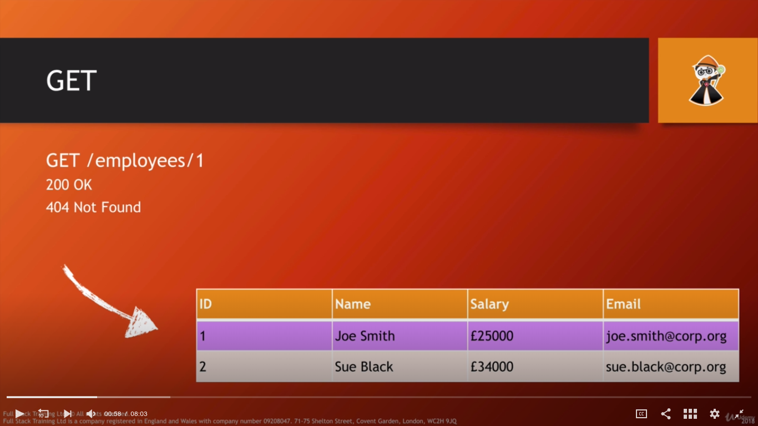
if we try to access an employee id 5 , we return code 404 not found

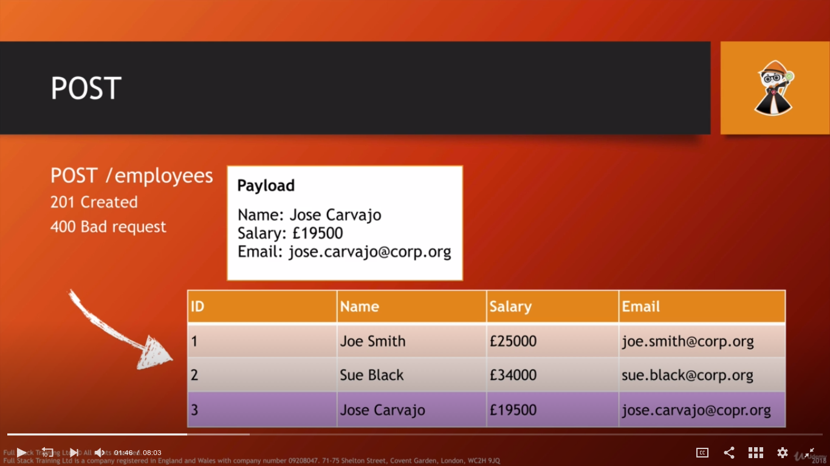
If we try to post employee in different format like instead of name , we provided username, we get 400 bad request error

